#TOP 10 MOVIES BY THEIR RATINGS
SELECT title, MAX(rating) AS max_rating FROM `imdb_movie_data` GROUP BY title ORDER BY max_rating DESC LIMIT 0, 10;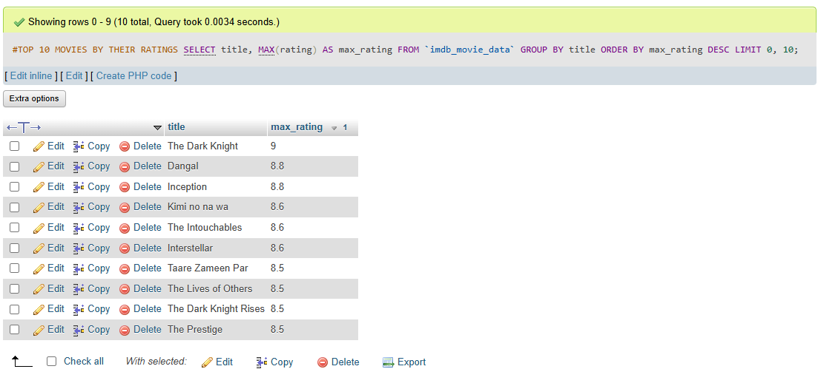

#TOP 6 MOVIES BY THEIR REVENUE
SELECT title, MAX(revenue_millions) AS `revenue_millions` FROM `imdb_movie_data` GROUP BY title ORDER BY revenue_millions DESC LIMIT 0, 6;
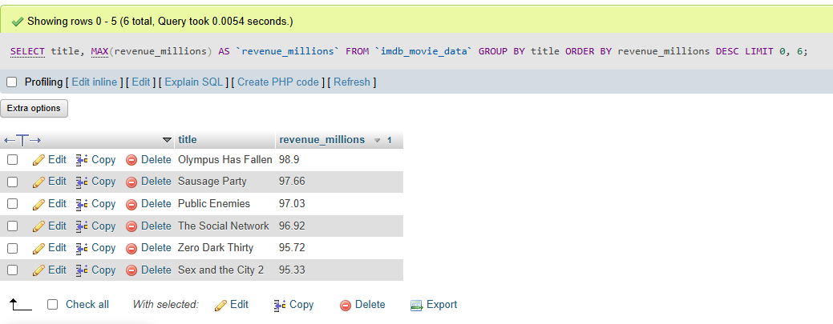

#GENRE WISE MOVIES COUNT
SELECT TRIM(SUBSTRING_INDEX(genre, ',', 1)) AS main_genre, COUNT(*) AS total_movies FROM `imdb_movie_data` GROUP BY main_genre ORDER BY total_movies DESC;
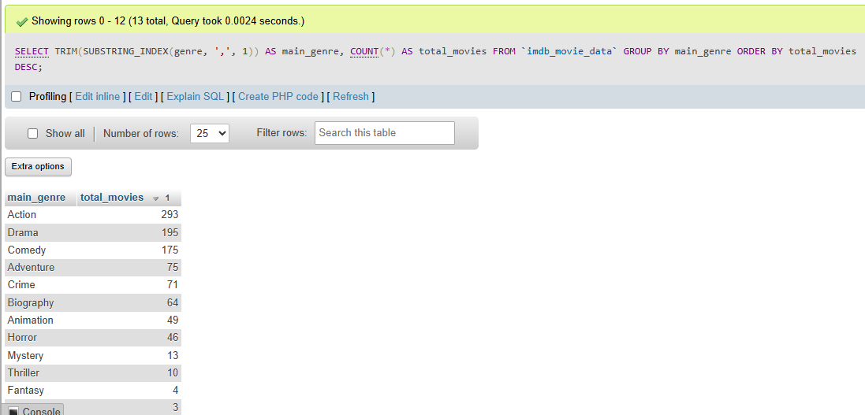

#DIRECTOR NAME WHO RELEASES MOST
MOVIES SELECT director, COUNT(director) AS director_count FROM `imdb_movie_data` GROUP BY director ORDER BY director_count DESC LIMIT 0, 10;
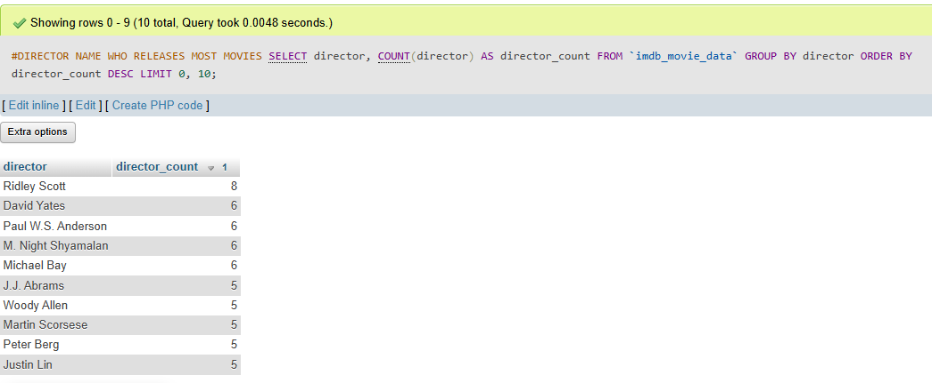

#TOP 10 MOVIES BY THEIR RUNTIME IN MINUTES
SELECT title, MAX(runtime_mi) AS max_runtime_mi FROM `imdb_movie_data` GROUP BY title ORDER BY max_runtime_mi DESC LIMIT 0, 10;
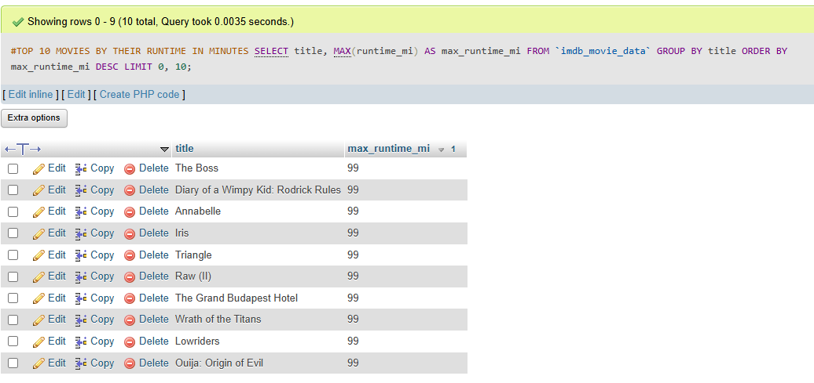
#TOP 10 ACTORS BY THEIR MOVIES COUNT
SELECT TRIM(SUBSTRING_INDEX(actors, ',', 1)) AS main_actors, COUNT(*) AS total_movies FROM `imdb_movie_data` GROUP BY main_actors ORDER BY total_movies DESC LIMIT 0 ,10;
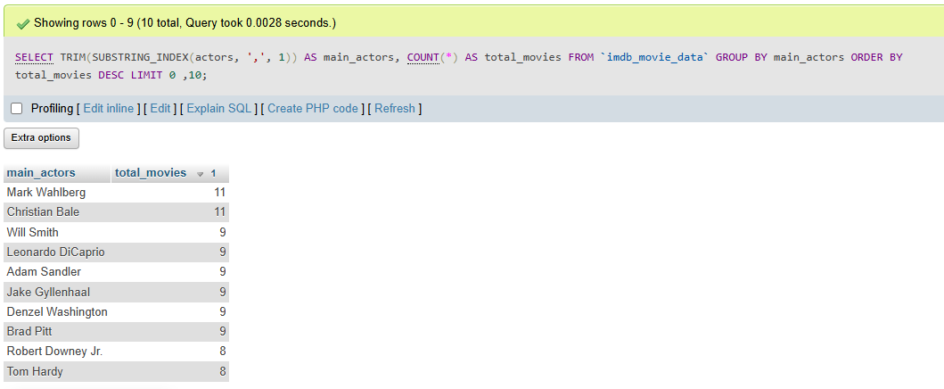

#TOP 10 MOVIES WHO GOT MAX VOTES
SELECT title, MAX(votes) AS max_votes FROM `imdb_movie_data` GROUP BY title ORDER BY max_votes DESC;
